|  |
| --- |
| **How To Install An SSL Certificate In IIS 7** |
| **A-Way:**  After giving us the CSR, and once your certificate is ready for installation, you need to extract all of the files we provide. You must install all files on your server, **starting with the intermediate( root,then policy,then issuer) and finally your certificate**.  **To Install an SSL on Microsoft IIS 7**   1. To install the intermediate certificate, click **Start**, and then click **Run...**. 2. Type **mmc**, and then click **OK**. The Microsoft Management Console (Console) window opens. 3. In the **Console1** window, click the **File** menu, and then select **Add/Remove Snap-in**. 4. In the **Add or Remove Snap-in window**, select **Certificates**, and then click **Add**. 5. In the **Certificates snap-in** window, select **Computer Account**, and then click **Next**. 6. In the **Select Computer** window, select **Local Computer**, and then click **Finish**. 7. In the **Add or Remove Snap-in** window, click **OK**. 8. In the **Console1** window, click **+** to expand the folder. 9. Right-click **Intermediate Certification Authorities**, mouse-over **All Tasks**, and then click **Import**. 10. In the **Certificate Import Wizard** window, click **Next**. 11. Click **Browse** to find the intermediate certificate file. 12. In the **Open** window, change the file extension filter to **PKCS #7 Certificates (*.spc;*.p7b)**, select the **{Microsoft IIS (*.p7b)}** file located on your SSL.com order page, and then click **Open**. 13. In the **Certificate Import Wizard** window, click **Next**. 14. Select **Place all certificates in the following store**, and then click **Browse**. 15. In the **Select Certificate Store** window, select **Intermediate Certification Authorities**, and then click **OK**. 16. In the **Certificate Import Wizard** window, click **Next**. 17. Click **Finish**. 18. Click **OK**. 19. Close the **Console 1** window, and then click **No** to remove the console settings. 20. To install the certificate, click **Start**, mouse-over **Administrative Tools**, and then click **Internet Services Manager**. 21. In the **Internet Information Services (IIS) Manager** window, select your server. 22. Double-click **Server Certificates**. 23. From the **Actions** panel on the right, click **Complete Certificate Request...**. 24. To locate your certificate file, click **...**. 25. In the **Open** window, select **\*.\*** as your file name extension, select your certificate (it might be saved as a .txt, .cer, or .crt), and then click **Open**. 26. In the **Complete Certificate Request** window, enter a **Friendly name** for the certificate file, and then click **OK**. 27. In the **Internet Information Services (IIS) Manager** window, select the name of the server where you installed the certificate. 28. Click + beside **Sites**, select the site to secure with the SSL certificate. 29. In the **Actions** panel on the right, click **Bindings...**. 30. Click **Add...**. 31. In the **Add Site Binding** window:     * For **Type**, select **https**.     * For **IP address**, select **All Unassigned**, or the IP address of the site.     * For **Port**, type **443**.     * For **SSL Certificate**, select the SSL certificate you just installed, and then click **OK**. 32. Close the **Site Bindings** window. 33. Close the **Internet Information Services (IIS) Manager** window.   Your SSL Certificate is installed. Visit your website with HTTPS to verify the installation. |

**B-Way:**

# Install SSL Certificate IIS 7

# Download and copy your certificate files to your server

.

1. Rename the file your_domain_com.p7b to your_domain_com.cer

# Install the PKCS#7 SSL Server Certificate File

1. Open the **Internet Information Services (IIS) Manager**. From the **Start** button select **Programs**> **Administrative Tools** > **Internet Information Services Manager**.
2. In the IIS Manager, select the server node on the top left under **Connections**   
     
   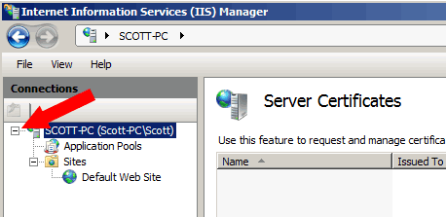
3. In the Features pane (the middle pane), double-click the **Server Certificates** option located under the IIS or Security heading (depending on your current group-by view).   
     
   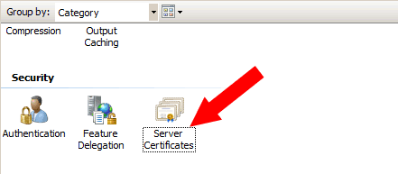
4. From the **Actions** pane on the top right, select **Complete Certificate Request**.   
     
   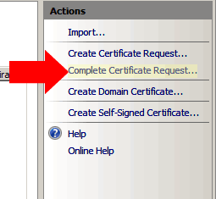
5. On the Complete Certificate Request page browse to the SSL certificate file your_domain_com.cer.   
     
   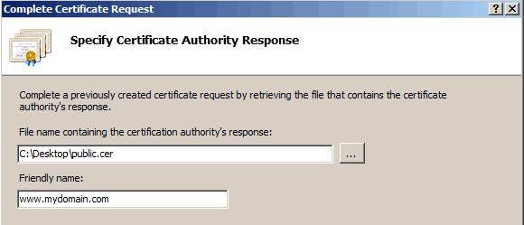
6. Next, type a friendly name for the certificate in the Friendly name box, and then click **OK**. Something like www.mydomain.com will do.
7. URGENT!! You may receive the following error: Cannot find the certificate request associated with this certificate file. A certificate request must be completed on the computer where it was created. You can ignore this error. Just click cancel. This is a [known bug](http://support.microsoft.com/kb/959216) in IIS7.
8. Your SSL server certificate is now installed on your server and you should see it listed in the **Server Certificates** view. Now you will need to configure your web site to use the certificate.

# Edit Bindings

1. If you have only one web site it will mostly likely be listed in IIS 7 as the **Default** web site. Select and right-click on the Default web site and select **Edit Bindings**.   
     
   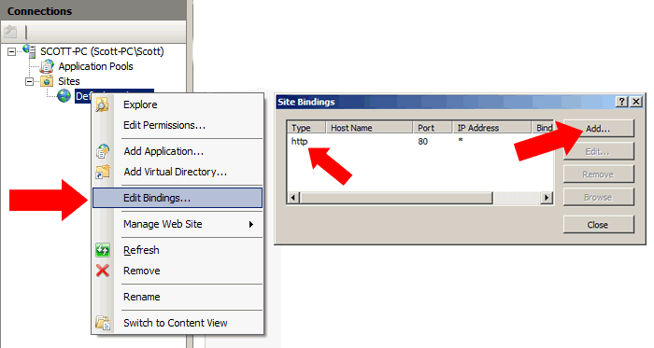  
   If you only see 'http' under the **Type** column of the Web Site Bindings dialog box click the **Add** button and select 'https' from the drop down box under Type.   
     
   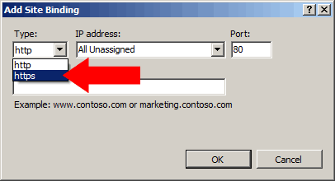  
   Then select the name of the SSL certificate from the SSL certificate list that you just installed and click **Ok**.   
     
   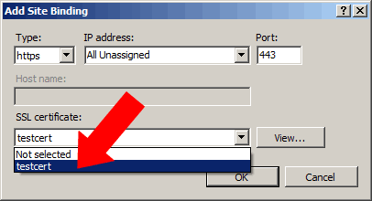  
   Then click **Close** to complete the Edit Bindings wizard.
2. URGENT!! You may receive the following error: There was an error while performing this operation Details: CertEnroll::CX509Enrollment::p_InstallResponse: ASN1 bad tag value met. 0x8009310b (ASN:276) You can ignore this error. Just click cancel. This is a [known bug](http://support.microsoft.com/kb/959216) in IIS7.

# Verify Installation

New To verify if your certificate is installed correctly, use our [Certificate Installation Checker](https://www.geocerts.com/ssl_checker).

Test your SSL certificate by using a browser to connect to your server. Use the **https** protocol directive. For example, if your SSL was issued to secure.mysite.com, enter https://secure.mysite.com into your browser.

Your browser's padlock icon Browser padlock will be displayed in the locked position if your certificate is installed correctly and the server is properly configured for SSL.

# Troubleshooting

For IIS SSL troubleshooting, Microsoft has designed a tool - [SSL Diagnostics](http://www.microsoft.com/downloads/details.aspx?familyid=cabea1d0-5a10-41bc-83d4-06c814265282&displaylang=en) - to aid in quickly identifying configuration problems in the IIS metabase, certificates, or certificate stores.